Malik Baptiste, John Baumann, Natalie Boggess, Cody Carlson, Megan Jadush,

Anders Snell

FAMU-FSU College of Engineering  2525 Pottsdamer St. Tallahassee, FL. 32310

Team 520: Underwater Driver GPS

9/13/2024

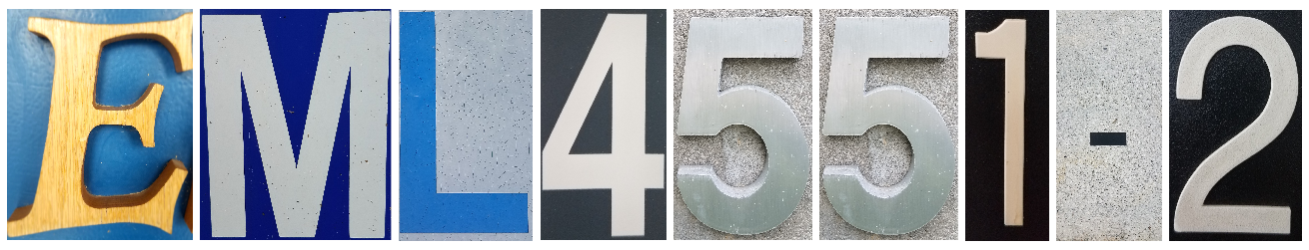

# Abstract

The abstract is a concise statement of the significant contents of your project. The abstract should be one paragraph of between 150 and 500 words. The abstract is not indents.

# Disclaimer

Your sponsor may require a disclaimer on the report. Especially if it is a government sponsored project or confidential project. If a disclaimer is not required delete this section.

# Acknowledgement

These remarks thank those that helped you complete your senior design project. Especially those who have sponsored the project, provided mentorship advice, and materials. 4

* Paragraph 1 thank sponsor!
* Paragraph 2 thank advisors.
* Paragraph 3 thank those that provided you materials and resources.
* Paragraph 4 thank anyone else who helped you.

Table of Contents

Abstract 1

Disclaimer 1

Acknowledgement 1

Table of Contents 1

List of Tables 1

List of Figures 1

Notation 1

Chapter One: EML 4551C 2

1.1 Project Scope 2

1.1.1 Project Description 2

1.1.2 Key Goals 2

1.1.3 Primary Market 2

1.1.4 Secondary Market 2

1.1.5 Assumptions 2

1.1.6 Stakeholders 2

1.2 Customer Needs 3

1.2.1 Investigation of Needs 3

1.2.2 Explanation of Results 4

1.3 Functional Decomposition 4

1.3.1 Introduction 4

1.3.2. Data Generation and Hierarchy Introduction 4

1.3.3 Hierarchy Chart Discussion 4

1.3.4 Connection to Systems 5

1.3.5 Smart Integration 5

1.3.6 Action and Outcome 5

1.3.7 Function Resolution 5

1.4 Target Summary 5

1.4.1 Derivation of Targets 5

1.4.2 Critical Targets 5

1.4.3 Measurement and Method of Validation 6

1.4.4 Summary 6

1.5 Concept Generation 6

1.5.1 Low Fidelity Concepts 6

1.5.2 Medium Fidelity Concepts 6

1.5.3 High Fidelity Concepts 6

1.5.4 Concept Generation Tools 6

1.6 Concept Selection 7

1.6.1 Binary Pairwise Comparison 7

1.6.2 House of Quality 7

1.6.3 Pugh Charts 7

1.6.4 Analytical Hierarchy Process 7

1.6.5 Final Concept Selection 7

1.8 Spring Project Plan 7

Chapter Two: EML 4552C 7

2.1 Spring Plan 7

Project Plan. 7

Build Plan. 7

Appendices 7

Appendix A: Code of Conduct 7

Appendix B: Functional Decomposition 8

Appendix C: Target Catalog 8

Appendix D: Work Breakdown Structure 9

Appendix E: Concept Generation 9

Appendix F: Images 9

Flush Left, Boldface, Uppercase and Lowercase 10

References 10

There are no sources in the current document. 10

# List of Tables

Table 1 *The Word Table and the Table Number are Normal Font and Flush Left. The Caption is Flush Left, Italicized, Uppercase and Lowercase* 10

# List of Figures

Figure 1. Flush left, normal font settings, sentence case, and ends with a period. 9

# Notation

|  |  |
| --- | --- |
| A17 | Steering Column Angle |
| A27 | Pan Angle |
| A40 | Back Angle |
| A42 | Hip Angle |
| AAA | American Automobile Association |
| AARP | American Association of Retired Persons |
| AHP | Accelerator Heel Point |
| ANOVA | Analysis of Variance |
| AOTA | American Occupational Therapy Association |
| ASA | American Society on Aging |
| BA | Back Angle |
| BOF | Ball of Foot |
| BOFRP | Ball of Foot Reference Point |
| CAD | Computer Aided Design |
| CDC | Centers for Disease Control and Prevention |
| CU-ICAR | Clemson University - International Center for Automotive Research |
| DDI | Driver Death per Involvement Ratio |
| DIT | Driver Involvement per Vehicle Mile Traveled |
| Difference | Difference between the calculated and measured BOFRP to H-point |
| DRR | Death Rate Ratio |
| DRS | Driving Rehabilitation Specialist |
| EMM | Estimated Marginal Means |
| FARS | Fatality Analysis Reporting System |
| FMVSS | Federal Motor Vehicle Safety Standard |
| GES | General Estimates System |
| GHS | Greenville Health System |
| H13 | Steering Wheel Thigh Clearance |
| H17 | Wheel Center to Heel Pont |
| H30 | H-point to accelerator heel point |
| HPD | H-point Design Tool |
| HPM | H-point Machine |
| HPM-II | H-point Machine II |
| HT | H-point Travel |
|  |  |
|  |  |
|  |  |

# Chapter One: EML 4551C

## 1.1 Project Scope

### 1.1.1 Project Description

With current technology, GPS signals are incapable of penetrating through water effectively, as they rely on radio waves to function. The objective of this project is to create a system capable of recording a diver’s position while submerged. Dr. Rassweiler’s current setup consists of a handheld GPS in a waterproof Pelican case (Figure 1, Appendix F) floating on the ocean surface and tied to him with a nylon string. The application of these location data points will be for Dr. Rassweiler to track the health and stability of the coral reef in specific areas by plotting spots where he notices diseased corals.

### 1.1.2 Key Goals

The system will be able to reliably work at a depth underwater up to 8-10 meters. This allows the user to be able to freely mark locations at any point of the dive area described.

The product will be accurate within a 6-meter diameter standard (GPS public industry standard). The standard range of a GPS is accurate within a five (5) meter margin when under open sky conditions (Spatial Post, 2023). By negating the user’s error and maintaining the accuracy within a smaller margin allows the data of where the coral is to be more precise.

The product will be portable, capable of launching from the shore, require minimal setup, and will be easy to get the resulting data from the system post-dive. The product will also be able to travel easily, taken in a plane carry-on, checked bag, or thrown in the car.

### 1.1.3 Primary Market

Our Primary Market consists of Dr. Rassweiler and Oceanographers with an interest in improving their portable underwater mapping capabilities. Since GPS radio waves do not work underwater, being able to accurately locate current positioning is a necessity to markets that require precise positioning for their research. With this project, productivity can be improved as more accurate data may be collected.

1.1.4 Secondary Market

The Secondary Market consists of companies operating in the commercial fishing and underwater exploration industries, that could want to track their crab traps or discoveries, respectively. The product may also appeal to recreational fishermen,divers, and marine sanctuaries for various applications like locating wildlife.

### 1.1.5 Assumptions

It is assumed that users will be within 8-10 meters of the water’s surface. It is also assumed that this product will be used in waters with high visibility (such as the Caribbean, 40-50 feet of visibility). It is assumed that the user has access to a watch and a waterproof notepad to mark time. The environment may be very windy (15-20 knots) with some smaller waves (2-3 feet max) and temperatures around 82°F. The device is designed for up to 90 minutes of use, which is the maximum dive duration of Dr. Rassweiler. The diver will be able to attach part of the device to their person during the dive. The device must be capable of launching from a very rocky or cliff-like shore. It is assumed that the user already has a good digital map of the surrounding area. The current device can be either modified or replaced.

1.1.6 Stakeholders

The stakeholders for this project include Dr. Andrew Rassweiler and the Rassweiler Laboratory, as they are sponsoring the project. Additionally, Dr. Shayne McConomy and the teaching assistants are stakeholders for the project, as they are the senior design instructors and advisors. Dr. Jonathan Clark will also act as a stakeholder as he will advise our team throughout the project.

*Table 1: Stakeholder Investment Matrix*

|  |  |  |  |  |
| --- | --- | --- | --- | --- |
|  | Investors | Decision Makers | Advisors | Receivers |
| Sponsor | Dr. Rassweiler | Dr. Rassweiler | N/A | Dr. Rassweiler |
| Manager | N/A | Dr. McConomy  Team 520 | Dr. McConomy | N/A |
| Experts | Ocean Researchers | N/A | Dr. Clark  Elias Haase | Dr. Rassweiler |
| Operators | Dr. Rassweiler  Rassweiler Lab | Dr. Rassweiler | Dr. Rassweiler  Elias Haase | Dr. Rassweiler |
| General Readers | SCUBA divers  Ocean research companies  Freedivers | N/A | N/A | Divers that work at ocean research companies |

## 1.2 Customer Needs

### 1.2.1 Investigation of Needs

Dr. Rassweiler and the Rassweiler Laboratory has partnered with the FAMU-FSU College of Engineering to create a system to record a scuba diver’s position while underwater to properly mark the location of sick coral. To determine the needs and wants of Dr. Rassweiler for the underwater GPS system, Team 520 met with him on September 10th of 2024 to discuss the project via a Zoom meeting. The team prepared a list of questions to better understand the problem Dr. Rassweiler was facing. The questions were formed and asked in a generic, open-ended manner to prevent scope creep from occurring. The questions asked and the responses received can be seen below in Table 2.

The feedback obtained from the customer helped determine the most important aspects of the project and which areas to direct our efforts towards. The questions asked primarily consisted of the environment where Dr. Rassweiler will be diving and the current setup he is using. From each customer statement, a need was interpreted to understand the underlying requirements of the project. This step in the design process further defines our project and allows the team to transition into the next phase of our project.

*Table 2: Customer Statements and Interpreted Needs*

|  |  |  |
| --- | --- | --- |
| **Question to customer** | **Customer Statement** | **Interpreted Need** |
| What are the size restraints on the device? | I want the device to fit in a carry-on bag. | The device can be packed into a carry-on bag. |
| How deep do you normally dive when you would be using the device? | I would consider it a success for the device to work as far down as 8-10m. | The device can operate with the user down to 10m. |
| Do you normally conduct your research dives from a boat, the shore, or somewhere else? | I go into the ocean from the shore. | The device is easy to carry straight from the shore into the ocean. |
| Would you prefer a system with multiple items you leave to mark spots or a device that just records these locations? | I need the device to be easy for me to use in the ocean, I don’t want to be carrying around a bunch of pieces. | The device consists of 1 or 2 small pieces. |
| How long are your dives when you would be using this device? | It would never be longer than 90 minutes at a time. | The device’s battery lasts for at least 90 minutes. |
| Are you marking these locations so that you can come back to them later? | I have a good digital map of the area; my goal is to mark these locations onto my map to do analyses with them. | The device can log a digital location. |
| What is the biggest issue you are having? | The issue is that my current device leaves too large of a radius of where the sick coral is for me to plot its precise location. | The device can get a more precise reading of the diver’s location. |
| What are the shore conditions like? | The shore is very rocky and at some points clifflike. | The device is light and easy to maneuver. |
| What are the water conditions like? | The only extreme condition in the water is the wind, it is very windy. | The device still operates normally when experiencing high winds. |
| How do you feel about your current setup? | I don’t mind pulling it around and it would be fine if you used the same GPS I already have, I just want the locations to be more precise. |  |

### 1.2.2 Explanation of Results

Dr. Rassweiler was asked several questions regarding his pre-existing setup for the underwater GPS driver and its current capabilities. Through communication via Zoom and email, Team 520 gathered Dr. Rassweiler’s main concerns for the device and what was desired to make future dives easier and more exact. The device being developed will be lightweight, compact, and able to withstand being submerged in 8-10 meters of water to allow for easy transport and set up on land and in the water. The battery life will be ample for dives and the coral will be able to be located with accuracy and ease.

## 1.3 Functional Decomposition

### 1.3.1 Introduction

Functional decomposition is a problem-solving technique that breaks down a complex system, procedure, or process into smaller parts. The purpose of the functional decomposition is to identify the overall function that needs to be accomplished by organizing the functions into a hierarchy. Through identifying the customer needs, the project statement can be broken down into low level actions, which make up the subsystems. Incorporating this process helps recognize the steps that need to be taken to accomplish the project goal and produce a final project that satisfies the sponsor.

### 1.3.2. Data Generation and Hierarchy Introduction

The data generated in the hierarchy chart (Figure 1 below) comes from analysis of project objective, key goals, customer needs, and assumptions. Through brainstorming the team created systems and subsystems that are necessary for the project's purpose of tracking and recording a diver's position underwater. The team starts with the highest-level subsystems including data, physical structures, power, and sensors. These are then broken down into smaller substructures without being specific on how a system task will be accomplished.

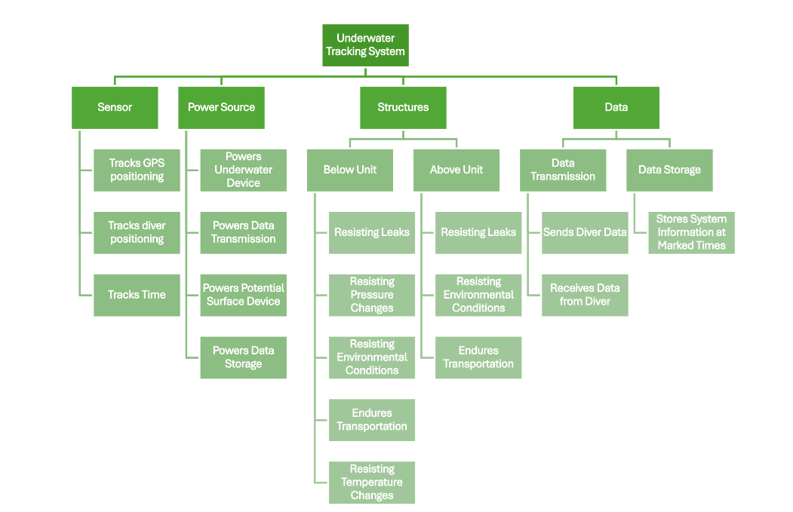 Figure 1: *Functional Decomposition Hierarchy Flow Chart*

### 1.3.3 Hierarchy Chart Discussion

The underwater diver project needs to consist of an underwater component to get a precise measurement of the diver and depending on the system chosen, a surface component to help with recalibrations of the underwater device. The main purpose of the project is to be able to log locations underwater. This can be broken into four main sections of need. These sections are sensors, power sources, structures, and data. Sensors will be needed to help locate the diver’s underwater position, which is the main goal. Power sources are needed to provide energy to all electronic components of the system, structures will be what composes of and/or holds our physical objects, and data is a necessary component since the goal is to log specific locations.

Sensors were delegated assuming that the system decided on is one that requires an above and below surface device. A GPS is needed to place the general location of the dive above the surface. Another sensor will be needed to locate the diver’s precise underwater position, most likely relative to the surface GPS. There will also need to be some sort of sensor to measure and track time as this will probably be necessary to find the exact location of the diver, or for the diver to use to look back on later to get the order they visited the logged data points.

Any electronic component needs power to operate so there would need to be a powering system for the underwater device and a powering system for the surface device, if there is one. Power will also be needed to transmit data wherever it needs to go and then to store the data points once they get to their destination.

The needed structures were split into above surface structures and below surface structures. Both the above and below surface structures will need to avoid leaks to ensure the components don’t get wet. They will also need to resist other environmental factors which mainly include wind and waves. Both above and below systems will also need to endure transportation. This means they can’t break being moved through a car, an airport, carry-on baggage, across the beach, and into the water. The below surface device also needs to resist pressure and temperature changes since it will be brought down to about 10m underwater.

Data is a large portion of this project as the main goal is precise data mapping. This was split up into two sections: data transmission and data storage. The data transmission could be happening between the underwater device and potential surface device(s) to find an exact location. Precise data points will also need to be transmitted to the location where they are being stored to be put on a map later. Data will also need to be stored of the precise locations at the times they are marked.

Table 3: Functional Decomposition Cross-Reference Table

|  |  |  |  |  |
| --- | --- | --- | --- | --- |
|  | System | | | |
| Function | Sensor | Power Source | Structures | Data |
| Tracks GPS Positioning | X |  |  | X |
| Tracks Diver Positioning | X |  |  | X |
| Tracks Time | X |  |  | X |
| Powers Underwater Device |  | X |  |  |
| Powers Data Transmission |  | X |  | X |
| Powers Potential Surface Device |  | X | X |  |
| Resisting Leaks |  |  | X |  |
| Resisting Pressure Changes | X | X | X |  |
| Resisting Environmental Conditions | X | X | X |  |
| Endures Transportation | X | X | X |  |
| Resisting Temperature Changes | X | X | X |  |
| Sends Diver Data | X |  | X | X |
| Receives Data from Diver | X |  | X | X |
| Stores System Information at Marked Times | X |  |  | X |

### 1.3.4 Connection to Systems

For the system to function properly, the design needs to fulfill the following functions: It needs sensors to acquire relevant data, a stable source of power to run its components, a structure that is capable of withstanding environmental conditions and protecting the systems inside, and data storage and transfer capabilities so that the user can interface and make use of the gathered information.

Within the target operational environment, the device should allow the user to operate unencumbered and still be able to reliably collect the necessary information to complete its tasks. Since it would be operating in a space that is highly detrimental to electronics, it is very important for the design to be leak-proof and properly sealed to prevent destruction of the system.

### 1.3.5 Smart Integration

For a system to function efficiently the main components of the device will have multiple subsystems as shown in Figure 1. The subsystem allows for the main systems to cross over in terms of function. By denoting where each system and subsystems cross over, it helps the team evaluate where the functions are similar as well as which functions will work together. For example, our device must be capable of communicating with other components of the device and log location. The systems *Sensor* & *Data,* shown in Table 3, work coincide to send, receive and store data.

### 1.3.6 Action and Outcome

To map the location of sick corals, the sponsor tows a GPS on the surface with a dive rope and marks times with his dive watch at points of interest, referencing the GPS post-dive to acquire the coordinates. This process introduces significant error, both due to the surface GPS being pulled from atop the diver and the GPS’s inaccuracy. Utilized in conjunction, the four primary subsystems of our system will enable the inaccuracy from the current process to be substantially reduced.

### 1.3.7 Function Resolution

The purpose of the underwater tracking system is tailored to the preservation of marine life, specifically the collection of precise locations of sick coral throughout the duration of a single oxygen tank dive. Additional capabilities for the system include a compact and wearable design that is attachable to a buoyancy control device, capable of withstanding ocean conditions and saltwater corrosion, integration between submerged and surface elements, and efficient battery management. This comprehensive functionality ensures that the user can record their location in real time, while storing all marked data points, to allow the user to easily return to the marked locations, ultimately saving time and reducing the error in the current configuration.

## 1.4 Target Summary

In Table 3, the systems, subsystems, and their functions were utilized to track the functions required for the underwater GPS to operate successfully. Each function under each subsystem requires a specific target and metric in order for the system to function properly. Each function receives a target (or numerical unit) that represents the standard that needs to be upheld to operate. A metric is also implemented with a specific unit of measurement that the element must hit to perform. For the functions to operate efficiently, the target and metric for each goal must be met.

### 1.4.1 Derivation of Targets

#### Sensors

The ability to attain the diver's global position is a critical function. This is the project objective and without it the project would be a failure. The target for this function is to be accurate within 5 meters. This is an improvement on the current 20 meters of the system being modified. The selection of 5 meters is based on current public GPS accuracy standards which say that GPS devices are generally accurate to within 5 meters. Accomplishing this target will mean the project has successfully brought the same level of GPS tracking from the surface to the underwater world.

Other functions in sensors include tracking the GPS’ position and tracking time. The GPS position should be accurate within 5 meters for the same reason as the diver position being 5 meters. The time should be accurately tracked within 1 second, this is easily accomplished using current technology, greater accuracy is possible but not necessary for our system.

#### Power Systems

A critical function of power is that it will provide 90 minutes of running time for our system. This target point was reached after speaking with the user and concluding that no dive goes longer than 60-90 minutes as they are “ready to come out.”

The system should be powered by 5 volts at all times. This target is based on current technology and electronic components which often have an input voltage range of 0-5 volts.

#### Structures

The most critical structure functions are keeping the system waterproof and able to endure transportation. It is close to impossible to have anything that is completely waterproof, but the goal is to get close to that as possible when diving in the assumed conditions and ranges. The system being waterproof is critical since the electronics involved will stop working if exposed to water and the main purpose of the project is for it to be underwater or on the water for a long period of time.

The other critical function of structures is to protect the internal components during travel through plane and car. This is critical as the device’s planned use is in the Caribbean which is a plane ride away. If it can’t survive the trip down, there is no point in designing or building it.

Another of the structures’ functions would be for the system to work normally when between 0°C and 50°C. The Caribbean stays around 27°C all year round so this range accounts for daily oscillations and the changes in temperature between the ocean surface and down to 10m.

The structure components need to be rated to at least 2.02 bar to be able to go down to 10m. If it is not rated down to 2.02 bar the pressure will become too much and damage the internal components and could also cause leaks.

The structure also needs to resist corrosion. Preventing long term corrosion from the salt water of the ocean will include picking proper materials and may include adding suggested preventative maintenance such as rinsing or scrubbing off the device with fresh water after each use.

#### Data

Data storage should be at least 32 GB, this target is based on current cheap storage devices such as flash drives or SD cards. This target gives the system ample storage for data at an affordable price.

Data transmission should occur at 9600 bits per second. This is based on a commonly used number for transmission between electronic components and microcontrollers such as the Arduino. It also provides data transmission at a rate that will allow for precision necessary to keep accurate location measurements.

### 1.4.2 Critical Targets

The critical targets and metric were defined as those that are essential for the system’s core functionality and safety. Regular targets and metrics, while they may affect performance if compromised, would not immediately result in system failure. If the critical targets fail, the system would be rendered inoperable or otherwise unsafe to use.

Table 4: *Critical Targets*

|  |  |  |  |
| --- | --- | --- | --- |
| **System:** | **Functions:** | **Target(s):** | **Metric(s):** |
| **Sensors** | **Tracks the diver’s global position** | **Attains diver’s position within 5 meters.** | **meters** |
| **Power** | **Duration** | **Lasts 90 minutes** | **minutes** |
| **Structure** | **Waterproofing** | **Water does not leak into the system container** | **Yes** |
| **Structure** | **Transportation** | **Structure can be safely transported by plane and car** | **Yes** |
| **Data** | **Data Transmission** | **9600 baud**  **(1200 bps)** | **bit/sec** |
| **Data** | **Data Storage** | **All data received fits on a 32 GB flash drive** | **Gigabyte** |

### 1.4.3 Measurement and Method of Validation

To achieve the intended goal of this project, tests on the key components of the design need to be performed to determine the accuracy of the parts. Regarding the sensors and tracking devices, tests will be performed locally. For the GPS currently in possession, it will be transported via vehicle and by walking. Then the recorded data will be checked and cross referenced with google maps to examine how closely the GPS system matches up with the established comparison. The INS will be tested in a similar method as the GPS, and will evaluate the accuracy of the object’s position, velocity, and orientation. The errors found will allow for better determination in keeping the current sensors or replacing them with more accurate devices.

With regards to the method that powers the system, a simple test of exhausting multiple brands of batteries under similar power draw will suffice. The battery should be capable of holding charge for the intended and specified duration of 90 minutes. The battery type that holds the longest charge under power draw will be chosen to support the design.

Additionally, the structure of the device needs to be capable of handling the environmental stresses that are expected for it to be under. The structure of the devices will hold the electrical components and thus testing for water leakage and sealing is just as important as the device being able to record diver position data. Once a design prototype is determined, it will be submerged for an extended period and then retrieved. The device will be inspected for leakage and whatever failure occurs will be corrected. The size of the device is also important and will be tested by placing it in a standard carry-on bag to determine the validity of the design.

With testing data transmission and storage, code can be written to measure transmission rate of the Arduino and that will provide the data necessary to make further decisions on that component.

### 1.4.4 Summary

The targets listed above in Table 4 and in Appendix C serve as reference points for our system as we begin testing and continue researching different components for our system. Along with using the targets for benchmarking, it will ensure the customer’s requirements for the system are kept in mind and met. The success of the project will rely on the satisfaction of all the critical targets. Along with the targets discussed, the targets not related to the functions will be the weight, the size, and the buoyancy of the system. The targets and metrics for this project are subject to change as the project progresses and the team learns more about the different components that will be tested.

## 1.5 Concept Generation

### 1.5.1 Low Fidelity Concepts

Low fidelity concepts are ideas which do not satisfy the majority of the needs or are realistically not obtainable due to budget constraints, time, or lack of technology. While these are not going to directly be used for the project, they serve as steppingstones to help develop new ideas based on pieces of these concepts. The full list of ideas which do not appear in the following subsections are displayed in Appendix E.

### 1.5.2 Medium Fidelity Concepts

Medium fidelity concepts consist of ideas which solve the majority of the needs for the project. They are more reasonable and obtainable compared to low fidelity concepts, but they pose potential problems or are not as complete compared to high fidelity concepts.

**Concept 1.**

One of the medium fidelity concepts is #63. This system would have a floating device in addition to the underwater diver. The diver will need to have an INS and an AHRS attached to them to help with logging their location and the orientation. The diver will also have one end of the rope connected to the GPS floating. There will also be some form of measurement for the amount of rope whether it is constant or being reeled in when loose.

**Concept 2.**

Another medium fidelity concept is #42. When considering our ideas that have a surface and underwater device, a large concern is recalibrating the INS with the GPS. An easy way to go about this would be for the diver to resurface every so often but Dr. Rassweiler has said that this would be very inconvenient and not preferred. Another option for the INS to be able to communicate with the GPS easily is by using cable between the two. This would be a good solution but would be very heavy to carry since he would need 10m worth.

**Concept 3.**

Another of our medium fidelity concepts is concept #62. This concept consists of a system that integrates three parts on board the diver’s physical person: An Inertial Navigation System (INS), and an Attitude and Heading Reference System (AHRS), and the utilizing the diver’s dive watch for depth, pressure, and time syncing. This setup will interact with surface GPS data to calculate accurate diver location data. This method can be employed as a system that updates his position in real time while on his dive, or the critical dive data can be stored and retrieved to be compiled after the dive.

**Concept 4.**

One of our medium fidelity concepts is #90. This idea consists of having a floating component with a GPS and a rope connected to the diver. The rope gets coiled automatically to keep tension in the rope so there wouldn’t be any concern with error from the rope curving. There would also be angle sensors on the rope to determine the direction of the location of the diver. This could also be paired with an INS on the diver to increase accuracy. If the automated rope coiling proves to be problematic to the diver moving around, the automated aspect could be removed and the error of the rope curving could be factored into the calculations, still using the angle sensors and possibly an INS on the diver.

**Concept 5.**

An additional medium fidelity concept is #96. This idea uses two angle detectors to determine the direction of a short rod attached to a floating device and a rope, which goes from the rod to the diver. The floating device will contain the current GPS being used. This would be paired with a barometer to detect the depth the diver is at, which would help determine the shape of the rope. This is necessary to determine the position of the floating device relative to the position of the diver to ensure accurate locations are being recorded. Additionally, electronic level sensors will be used to help determine the roll and yaw of the GPS. This will reduce the effects the waves and wind will have on the above surface system.

### 1.5.3 High Fidelity Concepts

High fidelity concepts are ideas which meet all the needs of the project and have the highest probability of succeeding.

**Concept 6.**

One of the high-fidelity concepts is #33, this comes from a combination of several concepts generated using the crap shoot. The concept is a combination of using an Inertial Navigation System (INS) and a pressure gauge attached to the diver. Then there is a cable instead of the current rope attaching the above water GPS and magnometer unit to the diver and his components. Finally, there is an angle detector(s) attached along the cable. This combined with the barometer can detect the location of the diver underwater. The idea behind this concept is to use two systems that can effectively detect diver global position (the INS and the cable angle). This may be a redundant process but would ensure accurate readings and could enable error detection.

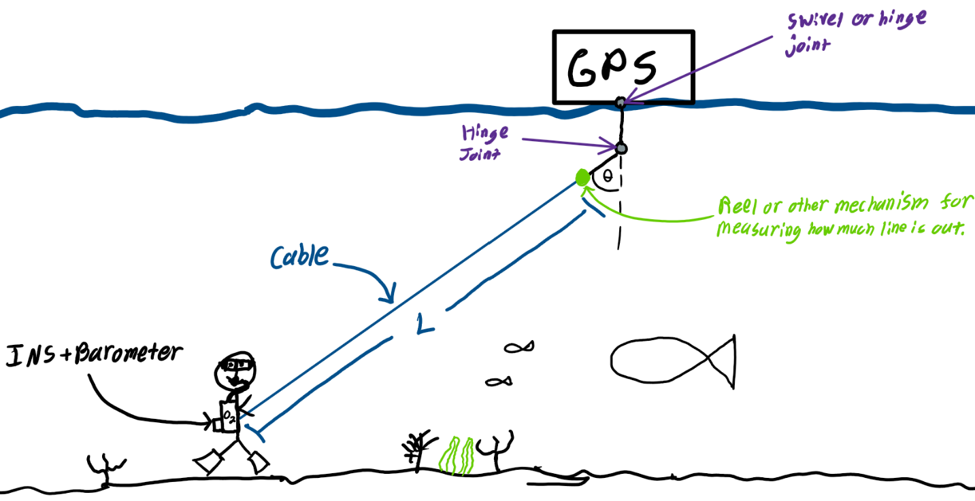 Figure 2: *Visual Representation of Concept 6*

**Concept 7.**

Another high-fidelity concept (#55) is to utilize LoRa triangular positioning technology, with two nodes on shore and one on the ocean subsystem. LoRa (long range radio communication) technology is already being used in emerging fields, such as providing internet access to communities that lack network infrastructure through satellite communication, as well as in various environmental applications. In this high-fidelity concept, an AHRS and pressure gauge will be on the diver to find the orientation and depth data for positioning determination. The diver, being the third node in the triangulation system, enables the generation of a navigational path based on his changing position. This path can then be cross-referenced with AHRS orientation data to ensure accuracy. The raft above the diver will house a GPS, to correct any cumulative drift in the generation of the path.

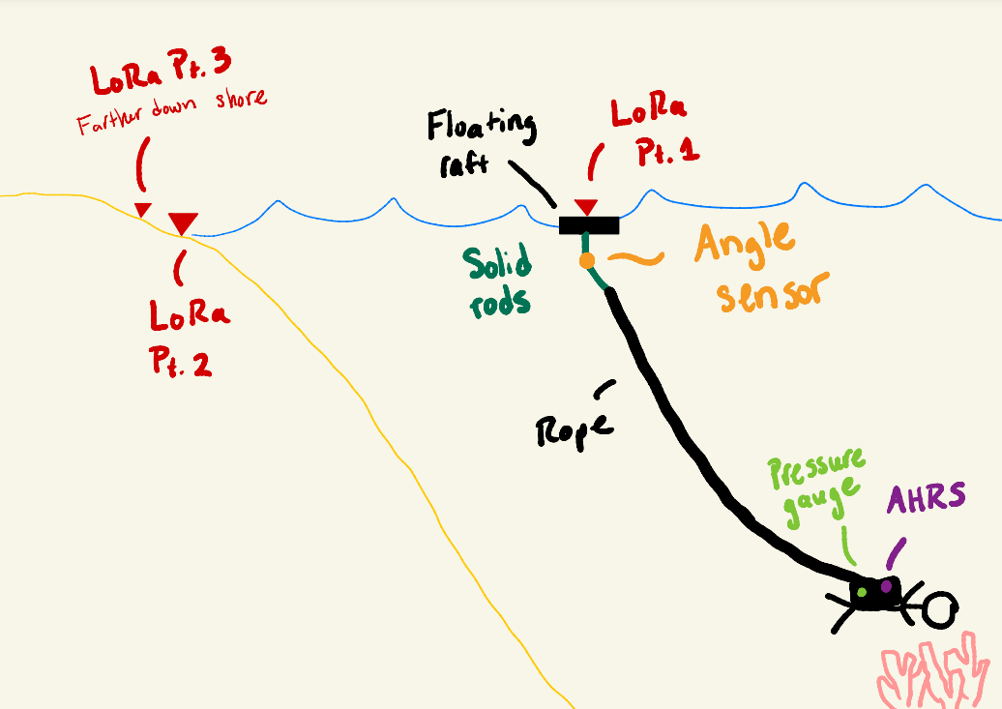

Figure 3: *Concept 7 Visualization*

**Concept 8.**

The third high-fidelity concept (#61) utilizes the Inertial Navigation System (INS) for positioning data. INS systems are currently used in various technologies that require path generation, such as in submarines, fighter jets, and rockets. Similar to high-fidelity concept #55, the AHRS and pressure gauge will be on the diver’s subsystem, and a raft will be utilized. Onboard the raft, a GPS will enable a second path generation to overlay with the INS path and correct cumulative drift.

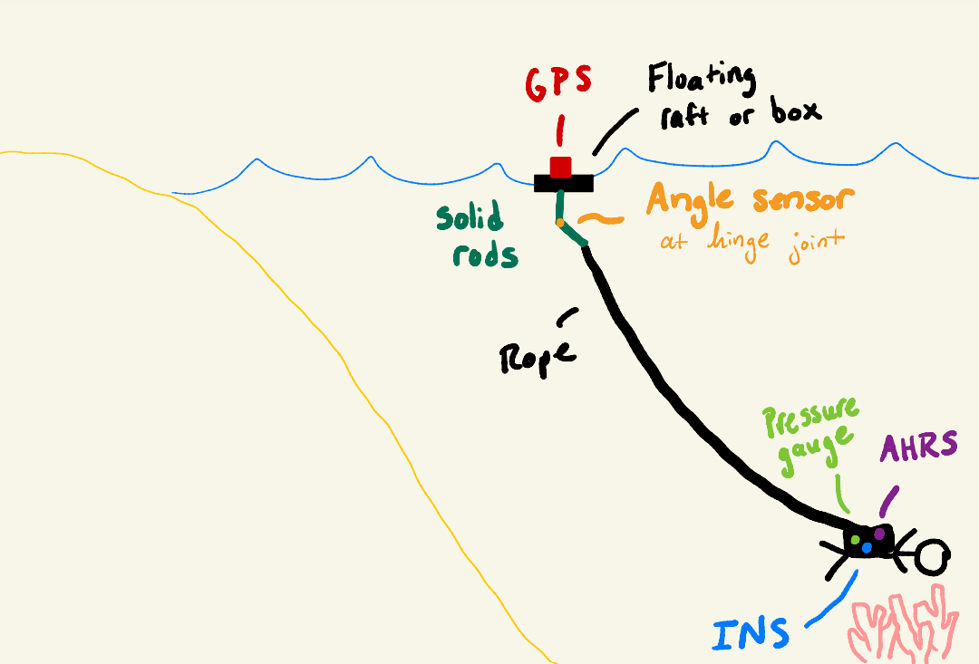Figure 4: *Concept 8 Visualization*

### 1.5.4 Concept Generation Tools

To move the ideation process along our team utilized the concept generation tool methods of Crap Shoot and Biomimicry.

#### Biomimicry

Biomimicry is the method of taking what is learned in nature, i.e. how organisms adapt and evolve to survive, and applying it to the concepts to help solve human problems (Biomimicry Institute). Much like Harbor Seals using their whiskers to sense movement in the water from their prey and follow the trail, our team came up with Concept 34 (Appendix E, ASKNATURE).

#### Morphological Chart

The morphological chart is effective because it investigates all possible options in

a problem with many solutions and combinations of solutions. The team divided the solution into 6 subproblems (navigation, Drift Correction, Attitude Heading Reference System (AHRS), above surface System, final variable, and specific technologies). Solution concepts were then generated for each subproblem. Then the team systematically combined subproblem solutions into 43 completed solutions and evaluated the results.

Table 5: *Morphological Chart*

|  |  |  |  |  |
| --- | --- | --- | --- | --- |
| **Subproblem** | **Solution Concepts** | | | |
| **Navigation** | Inertial Navigation System (INS) | Doppler Velocity Log (DVL) | Low Range (LoRa) Radio Communication | - |
| **Drift Correction** | GPS Raft & Rope & Angle Sensors | GPS on Above Surface Device | GPS on Underwater Device & Activated When Surfaced | - |
| **Attitude Heading Reference System (AHRS)** | Attitude Heading Reference System (AHRS) on Raft | Attitude Heading Reference System (AHRS) on the Diver | - | - |
| **Above Surface System (Optional – if** **Controlled)** | RC Drone | RC Raft | Autonomous Drone | Autonomous Raft |
| **Final Variable (Optional – if Raft Rope & Angle Sensors Utilized)** | Pressure Gauge (Depth) | Dive Watch Integration (Depth) | Mechanism to Measure out Line (Diagonal Distance) | - |
| **Specific Technologies - GPS** | Traditional | Differential | - | - |

## 1.6 Concept Selection

### 1.6.1 Binary Pairwise Comparison

Table 6: *Binary Pairwise Comparison*

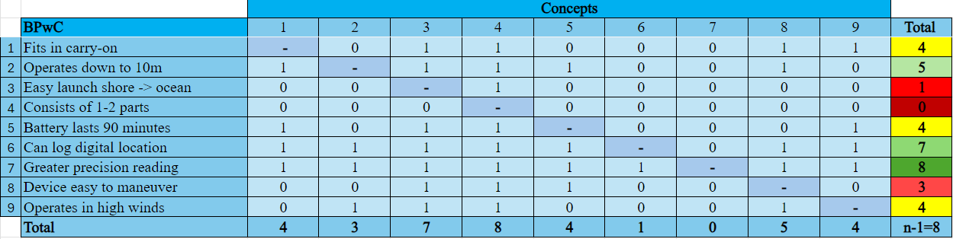 The Binary Pairwise Comparison (BPwC) matrix in Table 6 is utilized in the concept selection process to systematically compare and weigh objectives that were derived from the customer’s needs against each other, effectively ranking them in terms of their importance. Customer requirements are organized in columns and rows and then rows are assessed relative to columns, inputting a 1 if the row is greater need and a 0 if it is a lesser need. Naturally, needs weighed against themselves are omitted, represented by dashes diagonally descending through the matrix.

In the BPwC matrix for this project, fitting in a carry-on bag, operating at up to 10m underwater, being easy to launch from the shore, consisting of 1-2 parts, having a battery life of 90 minutes, being able to log digital location, offering a greater precision reading, being easy to maneuver, and being capable of operating in high winds were the nine customer needs that were inputted. The results determined that, with an Important Weight Factor (IWF) of 8, the system’s ability to offer greater precision readings is the most important need, as this is the primary objective of our sponsor with this project. Second, with an IWF of 7, being able to log the digital location of the diver is essential to the functionality of the system. Our third highest ranking, with an IWF of 5, is operability at up to 10m underwater. This aligns with intuition because while this is one of the main customer requirements, if the system falls short by a meter it is not necessarily detrimental to the success of the design. Three needs tied in fourth with IWF of 4: must fit in a carry-on, have a battery life of 90 minutes, and be able to operate in high winds. Descending further, easy to maneuver, easy to launch from shore, and consisting of 1-2 parts were ranked 7th ,8th, and 9th, with IWFs of 3, 1, and 0, respectively.

### 1.6.2 House of Quality

Table 7: *House of Quality*

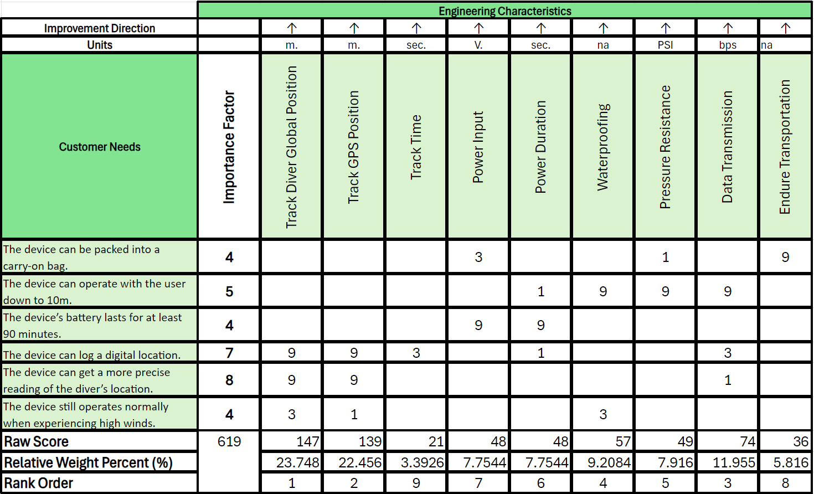 The results of the Pairwise Comparison in Table 6 were then used to start off the customer needs list in the House of Quality (HoQ) located in Table 7. The House of Quality (HoQ) lists the customer needs across the first column and the engineering characteristics are listed vertically across the fourth row. Using a series of 1s, 3s, and 9s, the team compares how important the factor is to the customer's certain need. The numbering sequence ranks as 1 being the lowest, 3 being the average, and 9 being the highest dependency. If the factor is not viable with the need, the spot is left blank. Comparing the engineering characteristics against the customer’s needs helps the team decide which factor has the highest relative weight factor. In this case the characteristic with the highest weight percent is “track diver global position”. Following the same process the next important factors are determined as “track GPS position”, “data transmission”, “waterproofing”, and “pressure resistant”. The percentage that is the highest determines the team's main goal for the project. For the underwater GPS diver, the main goal is to be able to track the diver’s global position. Without this feature, the diver will be unable to track not only their location, but the location of the sick coral they are tracking.

### 1.6.3 Pugh Charts

Pugh Charts are a systematic method for comparing and evaluating multiple concepts to a selected datum. The team used three iterations of Pugh Charts to evaluate the five medium fidelity concepts and three high fidelity concepts against each other to narrow down the pool of ideas. To begin the process, the team selected a well-rounded medium concept, Concept 90, to serve as the first datum. The remaining seven concepts are compared to the datum based on the selection criteria. If a concept performs better than the datum in a criterion, it will receive a plus (+). If a concept performs worse than the datum, it will receive a minus (-). If the team concludes that the datum and the concept are the same for a certain criterion, it will receive an ‘S’. At the end of each iteration, the number of plusses, minuses, and ‘S’s are counted and used to eliminate weaker concepts as well as picking a datum for the next iteration. This process continued until the team narrowed down the concepts to the two best performing concepts. Figure X, shown below, displays the five medium fidelity concepts and three high fidelity concepts used in this process.

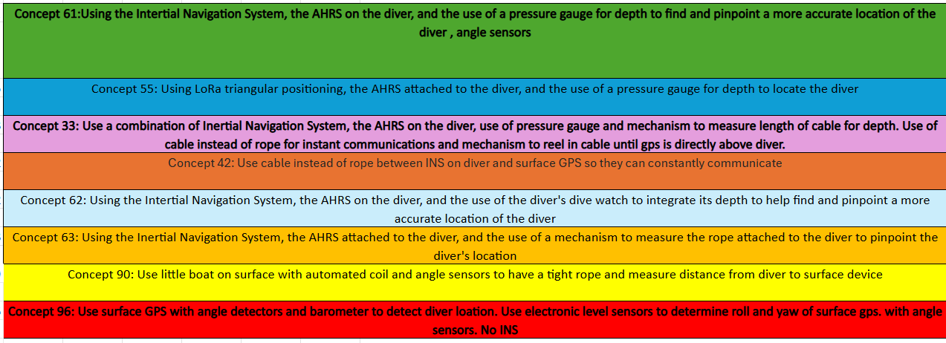Figure 5: *Medium and High-Fidelity Concepts*

As previously mentioned, Concept 90 was used as the datum for the first iteration of the Pugh Chart. Paired with the top five weighting engineering characteristics, found in the House of Quality, were used to evaluate the seven remaining concepts. The current system in place was also included in the Pugh Chart for comparison. The highest concepts from this iteration were Concept 61 and Concept 96 having a total of +4 and +3, respectively. Concepts 55, 42, and 63 were eliminated and Concept 62 was selected as the datum for the second iteration. Table 8 shows the results of all the concepts compared to the datum, Concept 90.

Table 8: *First Iteration of the Pugh Chart*

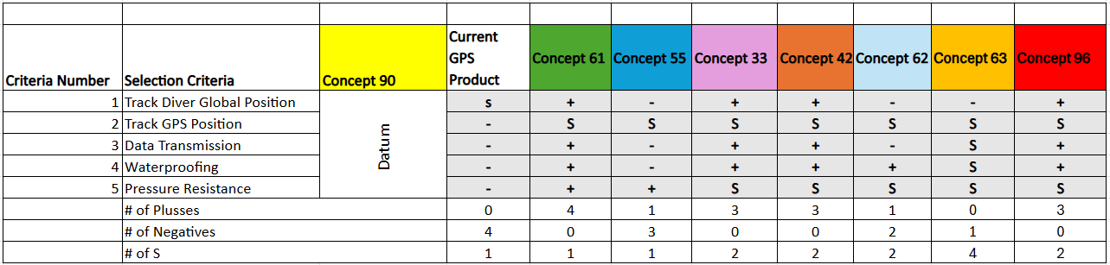

The second Pugh Chart (Table 9) used concept 62 as the datum since it seemed like a nice middle ground to compare the other concepts to. Concepts 61, 33, and 96 were chosen to compare since they scored well in the first Pugh Chart. Concept 42 also scored well but it was decided that although it would probably give the most accurate locations, it would be too heavy and frustrating for the diver to carry so it was ruled out. Concept 90 was also included in comparison since in the first Pugh chart it was used as a datum and never really got scored. The results of this were Concepts 61 and 33 scoring the highest.

Table 9: *Second Iteration of the Pugh Chart*

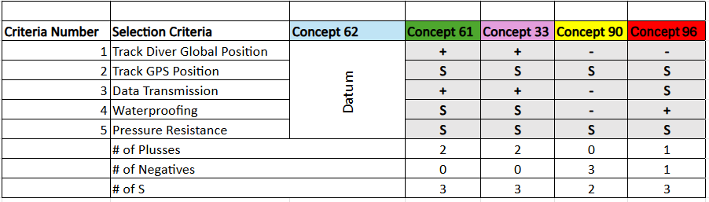 The last Pugh Chart (Table 10) that was done was comparing concept 61 and concept 33 against concept 96. Concept 96 was chosen as the datum because it scored well in the previous Pugh Chart and while it is a good idea, it would probably not be as accurate as the sponsor would like since an INS is not used. Concepts 61 and 33 were chosen to compare because they were the other two from the previous Pugh Chart that scored well. The result from this final Pugh Chart is that they scored exactly the same. This means that in order to pick a final concept winner, other factors will have to be considered other than the ones used as the selection criteria.

Table 10: *Final Iteration of the Pugh Chart*

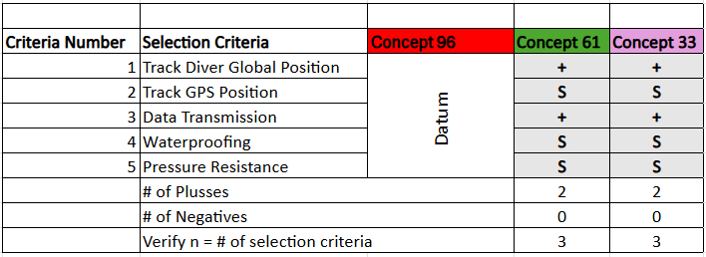

### 1.6.4 Analytical Hierarchy Process

The analytical hierarchy process (AHP) is useful in concept selection as it assigns numerical values to otherwise empirical comparisons. Like the BPwC, where customer needs are compared against each other, the AHP compares engineering characteristics against each other.

Table 11: *Criteria Comparison Matrix [C]*

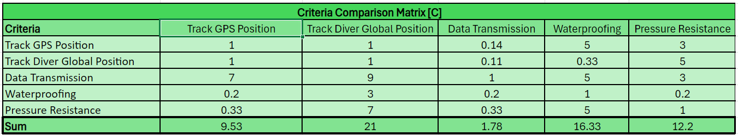 In the comparison matrix [C], the columns are weighted in relation to the rows. Odd numbers between 1-9 are assigned to each comparison, higher values denoting a greater weight for the column. Corresponding inverse comparisons, positioned opposite in reference to the diagonal descending line of self-comparisons (denoted with 1s), are assigned the inverse values of the odd number assigned to each comparison.

Table 12: *Normalized Criteria Comparison Matrix [NormC]*

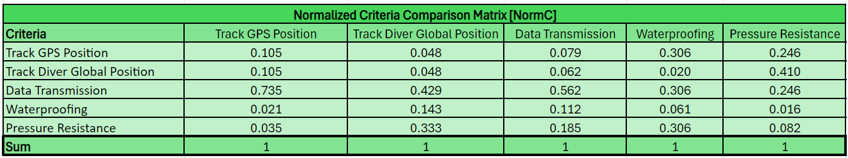

The normalized criteria comparison matrix [NormC], takes the element values in each of the previously identified locations and divides the element by the sum of the column. The resulting sum of each column should be 1. This matrix is important as the normalized values are used to calculate the criteria weights

Table 13: *Consistency Check*

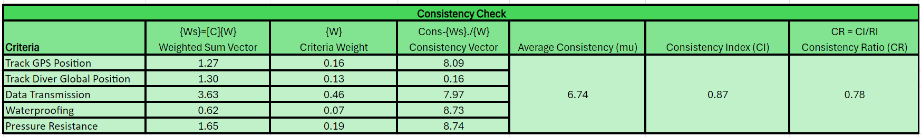

The consistency check references the criteria weights and criteria comparison matrices to check the consistency of the input data. First, criteria weights are matrix multiplied by the criteria comparison matrix rows to get the weighted sum vector. The consistency vector is equal to the weighted sum vector divided by the criteria weight. The consistency index is the (average consistency – number of concepts)/2. Finally, consistency ratio is consistency index divided by the Random Index Value (RI). RI is determined by the number of engineering criteria which is 5 so RI = 1.11.

### 1.6.5 Final Concept Selection

Since the last Pugh Chart resulted in two concepts with the same score, the team tried to look at these solutions from the sponsor’s point of view and realized that carrying a 10m long cable around would be too much. It wouldn’t be reflecting our customers’ needs of being easy to travel with and maneuver. Due to this and following the processes down from Table 6, team 520 has determined the final concept selection to be concept 61. To see a drawing of Concept 61, see Figure 4 under the Concept Generation section.

## 1.8 Spring Project Plan

# Chapter Two: EML 4552C

## 2.1 Spring Plan

### Project Plan.

### Build Plan.

# Appendices

# Appendix A: Code of Conduct

Mission Statement:

The mission of our group (Team 520) is to solve the GPS diving problem, sponsored by Dr. Rassweiler, to the best of our abilities under the advising of Dr. Clark. The team plans to accomplish this through the utilization of education, experiences, and skills amassed during their undergraduate careers at the FAMU-FSU College of Engineering.

Outside Obligations:

In Team 520, we acknowledge the outside obligations of team members throughout the completion of assignments. Project deadlines for both individual and group responsibilities are recognized as important, and a failure to meet deadlines is understood to be a poor reflection of the entire team. Members will accommodate into their schedules both outside obligations and tasked assignments.

Team Roles:

The table below displays the agreed team roles based on individual areas of interest and academic expertise. Team roles can be altered, or additional roles can be added throughout the semester. Work outside of the assigned roles will be given based on the workload of all the group members at the time it arises. Additional work will be assigned in a fair manner to ensure an individual is not constantly receiving all the work outside of the assigned roles. Regardless of specific roles, other members will still support one another with all work related to the project.

|  |  |
| --- | --- |
| **Team Members** | **Team Roles** |
| John Baumann | Design Engineer |
| Natalie Boggess | Marine Engineer |
| Cody Carlson | Software Engineer |
| Megan Jadush | Materials Engineer |
| Malik Jean-Baptiste | Robotics Engineer |
| Anders Snell | Mechatronics Engineer |

Communication:

Our group will be communicating in person and through Microsoft Teams, email, and GroupMe. The main source of communication will be through GroupMe. The main source of exchanging files will be through Microsoft Teams. We will all work to respond to our teammates, sponsors, and advisors within a 24-hour time frame during weekdays. If extenuating circumstances present themselves and prevent this from happening, the individual will make the team aware at their earliest convenience.

Dress Code:

For informal meetings and class time, there will not be a formal dress code. When meeting with the sponsor, the dress code will be business casual attire. For official presentations, the attire will be business attire consisting of a dress shirt with khakis or slacks. For Senior Design Day, the dress code will be business attire consisting of suits.

Attendance Policy:

When meeting for group collaborations we will generally meet after class to discuss plans. Since our availability does not allow full attendance in meetings outside of class, we will coordinate times and have at least two members present. Other members will be filled in on any missed information. For Sponsor and Advisor meetings, we will make time to attend but will consider and understand circumstances that prevent full attendance. If a team member cannot attend, they will notify the team an hour before the allotted meeting time.

Mandatory Team Bonding:

Once a month the team will go on a mandatory team bonding day to get food and drinks at a designated date, time, and place agreed upon by the team.

How to Notify Group:

In general, communication and notice in any form (in-person, email, teams, group-me, text) is fine. In a more urgent situation, it will be expected for a team member to notify the group via in-person discussion, group-me, or text.

How to Respond to People in Professional Meeting:

Professional meetings will use respectful conversation, and people will talk in turn. This allows for fluidity of the conversation while also allowing for people to fully communicate their ideas or questions.

Statement of Understanding:

By signing this document, you agree to the terms stated within the Code of Conduct:

__________________________________

John Baumann

______________________________________

Natalie Boggess

_______________________________________

Cody Carson

_______________________________________

Megan Jadush

_______________________________________

Anders Snell

__________________________

Malik Jean-Baptiste

Team vs Individual Grading

If our team has continuous issues with a teammate not contributing to assignments, we will discuss with Dr. McConomy about changing to individual grading instead of team grading.

When to Involve McConomy:

If an issue arises that lasts for longer than 3 days, the team will call a meeting where all members are present to resolve the issue. Alternatively, the issue will be discussed at the next scheduled team meeting and the best plan of action will be decided.

If we have tried to contact a team member or sponsor multiple times with no response for a week, we will discuss the matter with Dr. McConomy.

We hope Dr. McConomy will also try to contact the team member(s) and/or sponsor that we haven’t been able to contact.

How to Amend:

If a member would like to amend the code of conduct, it will be discussed with the group. A vote will then be held and will require 4/6 members to agree for the code of conduct to be altered. If a vote does not meet the required number of members, the team will discuss and resolve any problems prior to the next discussed meeting.

# Appendix B: Functional Decomposition



# Appendix C: Target Catalog

|  |  |  |  |
| --- | --- | --- | --- |
| **System:** | **Functions:** | **Target(s):** | **Metric(s):** |
| **Sensors** | **Tracks the diver’s global position** | **Attains diver’s position within 5 meters.** | **meters** |
| Sensors | Tracks GPS’s position | Attains GPS position within 5 meters. | meters |
| Sensors | Tracks Time | Time accurately tracked within one second | seconds |
| Power | Input | 5 volts | voltage |
| **Power** | **Duration** | **Lasts 90 minutes** | **minutes** |
| **Structure** | **Waterproofing** | **Water does not leak into the system container** | **Yes** |
| Structure | Temperature | 0°C < Withstands < 50°C | °C |
| Structure | Pressure | Withstands at least 2.02bar | Bar |
| Structure | Corrosion | Structure is not negatively impacted by corrosion when properly maintained | Yes |
| **Structure** | **Transportation** | **Structure can be safely transported by plane and car** | **Yes** |
| **Data** | **Data Transmission** | **9600 bits per second** | **bit/sec** |
| **Data** | **Data Storage** | **All data received fits on a 32 GB flash drive** | **Gigabyte** |
| N/A | | The entire system will be no greater than 10 kilograms | Grams |
| N/A | | It will fit in a carry-on bag | Meters |
| N/A | | The underwater portion of the system will be neutrally buoyant | Newtons |

# Appendix D: Work Breakdown Structure

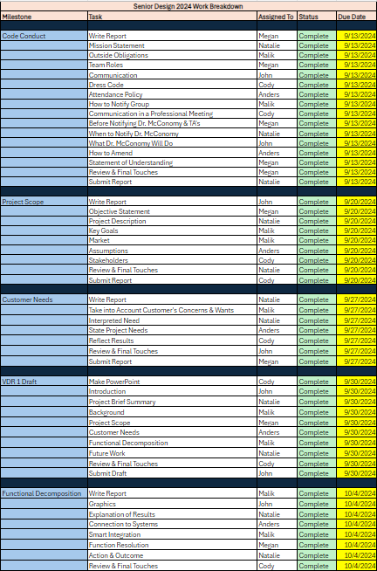

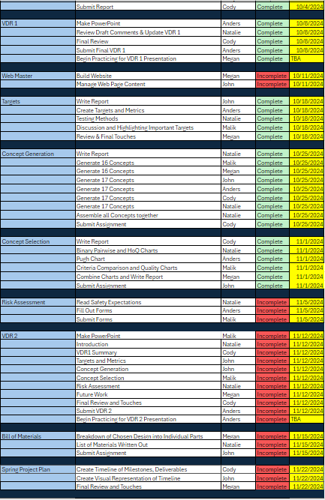

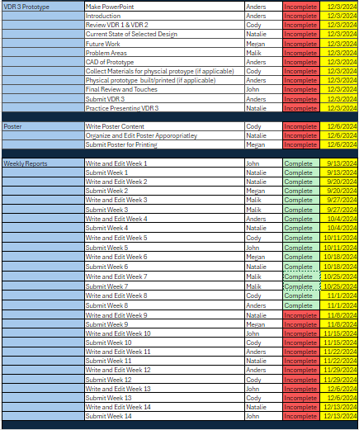

# Appendix E: Concept Generation

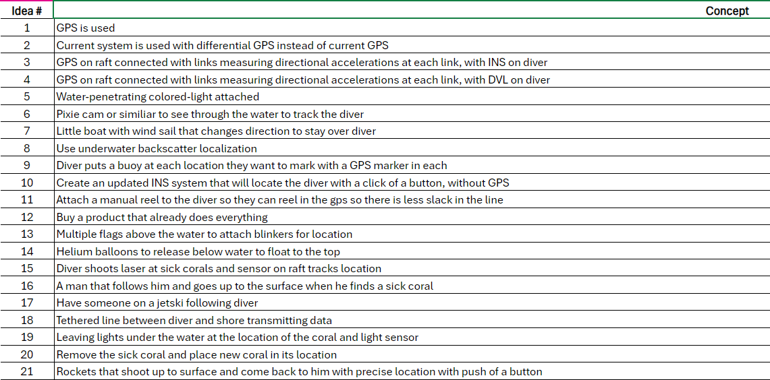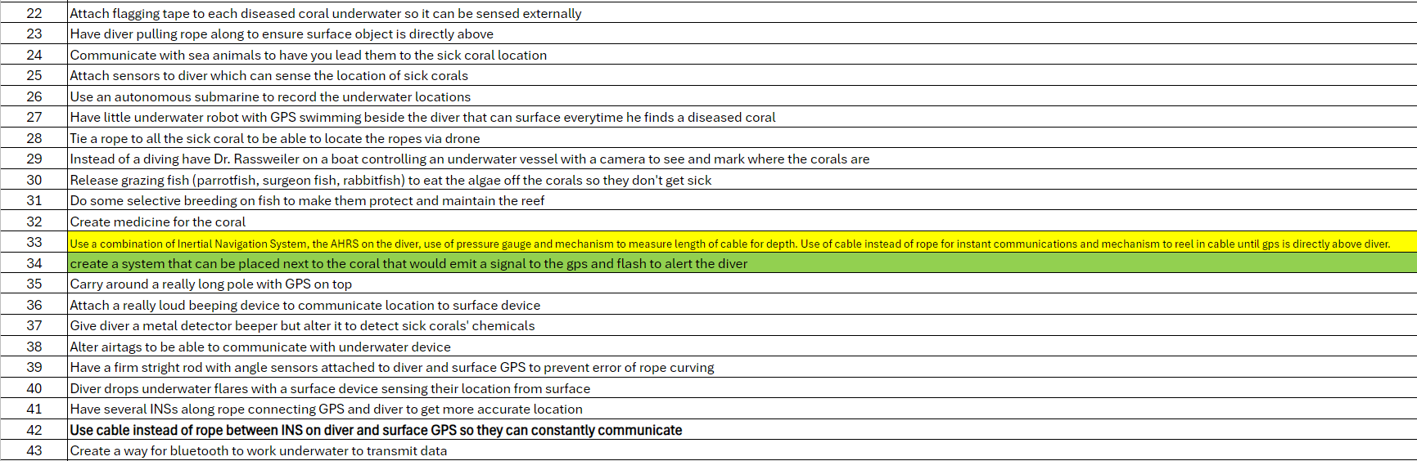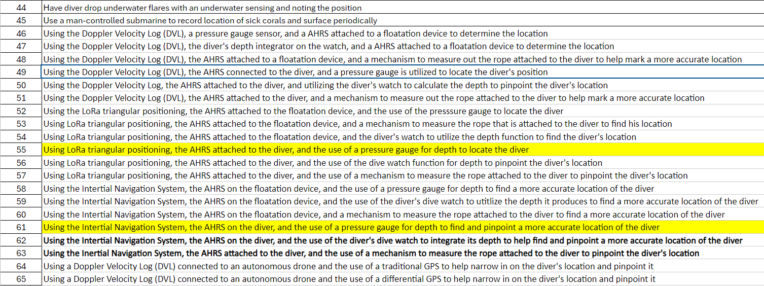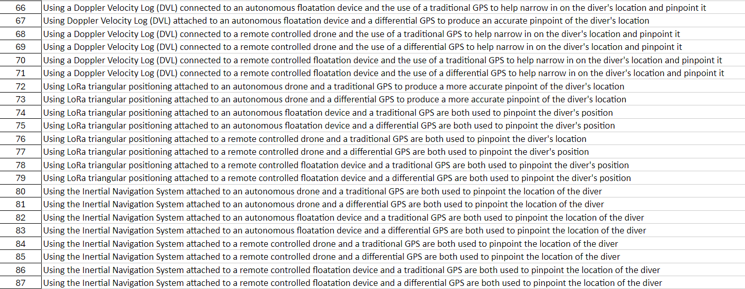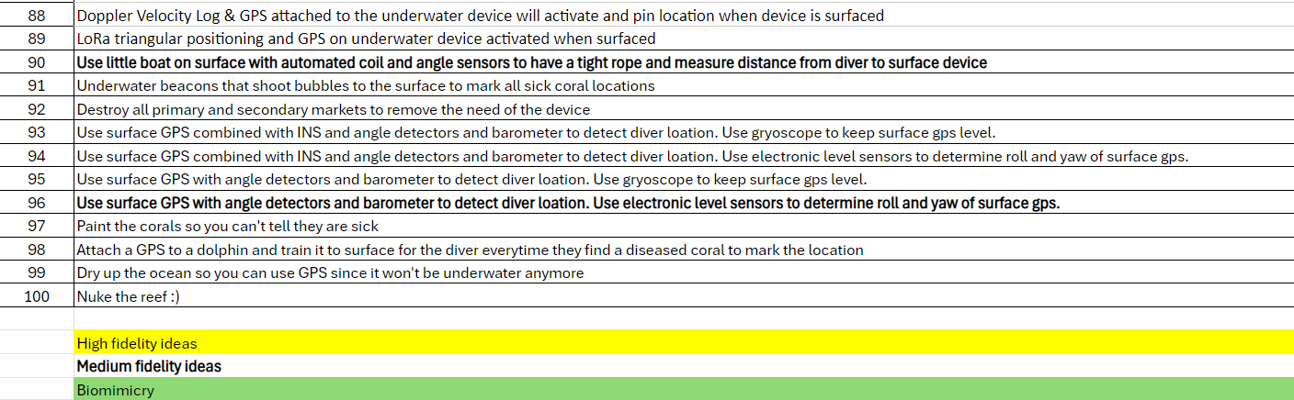

# Appendix F: Images

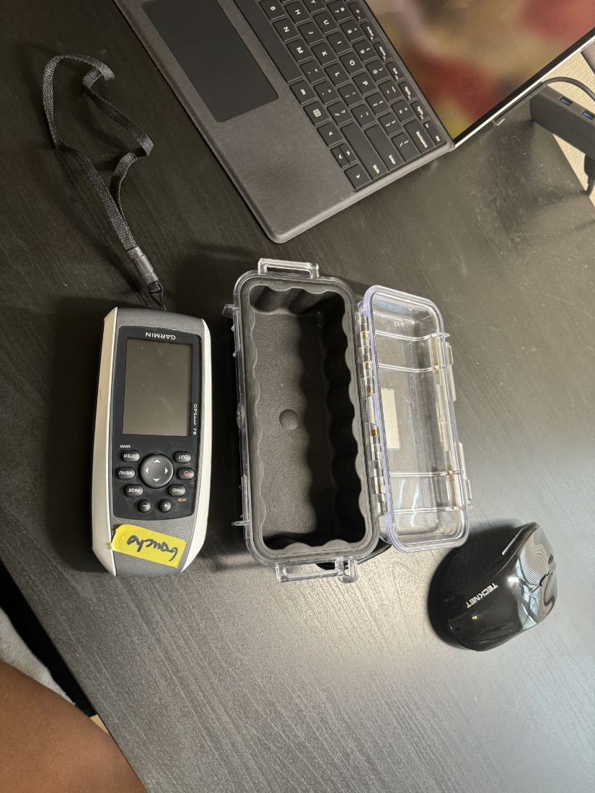

Figure 1: Current GPS Next to Pelican Case

Table 1  
*The Word Table and the Table Number are Normal Font and Flush Left. The Caption is Flush Left, Italicized, Uppercase and Lowercase*

|  |  |
| --- | --- |
| Level of heading | Format |
| 1 | **Centered, Boldface, Uppercase and Lowercase Heading** |
| 2 | Flush Left, Boldface, Uppercase and Lowercase |
| 3 | Indented, boldface lowercase paragraph heading ending with a period |
| 4 | Indented, boldface, italicized, lowercase paragraph heading ending with a period. |
| 5 | Indented, italicized, lowercase paragraph heading ending with a period. |

# References

# There are no sources in the current document.

*How Accurate Is GPS? Exploring Factors, Standards, and Improvements*. (2023, April 17). Retrieved from SpatialPost: <https://www.spatialpost.com/how-accurate-is-gps/#google_vignette>

*How Seal Whiskers Track Prey Underwater*. (n.d.). Retrieved from AskNature: <https://asknature.org/strategy/whiskers-sense-prey-movement/>

*What is Biomimicry?* (n.d.). Retrieved from Biomimicry Institute: <https://biomimicry.org/inspiration/what-is-biomimicry/#:~:text=Biomimicry%20is%20a%20practice%20that,with%20all%20life%20on%20earth>.